Day-2(Pattern programming):
Pyramid Patterns
Alphabet Patterns
Number Patterns
Triangle Patterns
Number Systems
Fibonacci
Palindromic
Strong Number
ArmStrong Number
Factorial etc.
---------------------------------------------------------------------------------------------------------------------------------------------------------
Q1.WAP to print following pattern.
Input:
5
5

Output:
11111
22222
33333
44444
55555

Solution:

import java.util.*;
class HelloWorld {
public static void main(String[] args) {
Scanner sc = new Scanner(System.in);
int n = sc.nextInt();

for(int i=1;i<=n;i++){
for(int j=1;j<=n;j++){
System.out.print(i);
}
System.out.println();
}
}
}

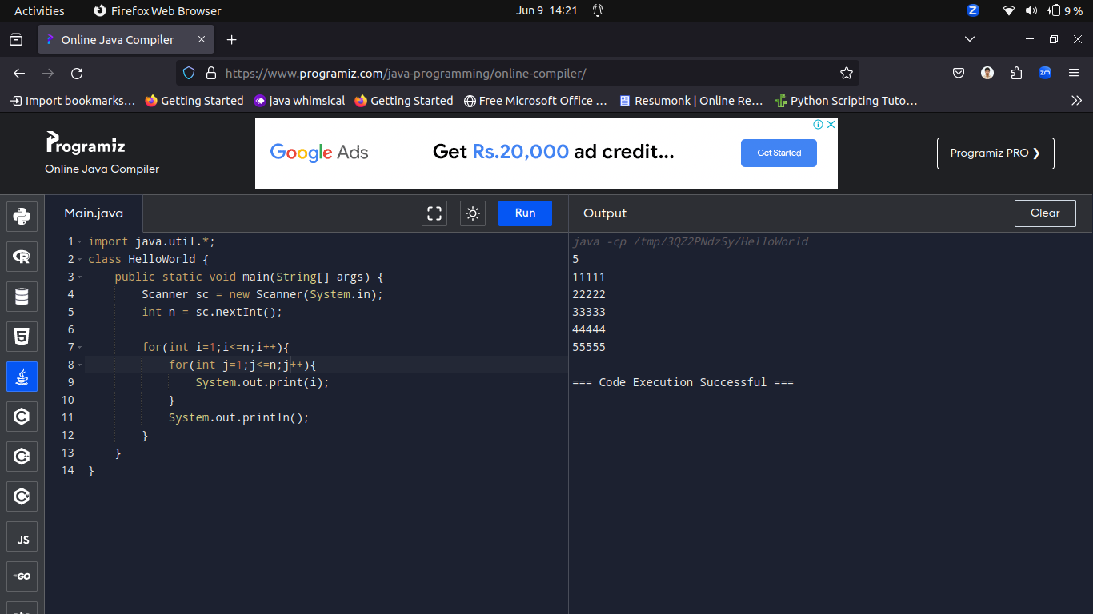
---------------------------------------------------------------------------------------------------------------------------------------------------------
Q2.WAP to print following pattern.
Input:
5
5

Output:
10101
01010
10101
01010
10101

Solution:

import java.util.*;
class HelloWorld {
public static void main(String[] args) {
Scanner sc = new Scanner(System.in);
int n = sc.nextInt();
int k=1;
for(int i=1;i<=n;i++){
for(int j=1;j<=n;j++){
if(k%2==0)
System.out.print(0);
else
System.out.print(1);
k++;
}
System.out.println();
}
}
}

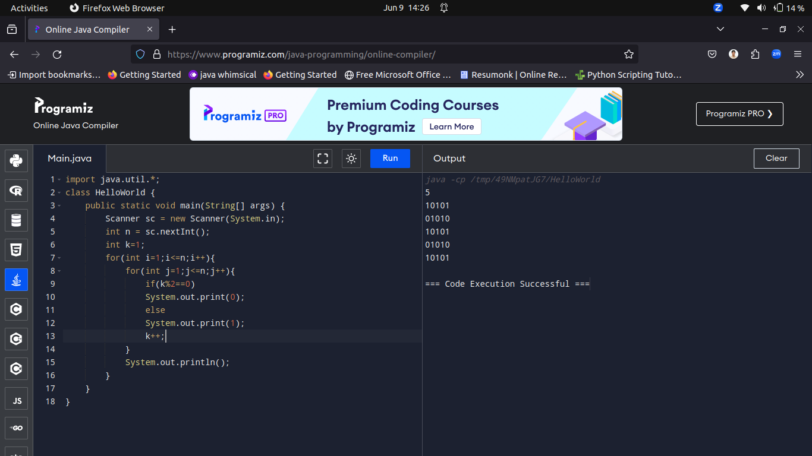

---------------------------------------------------------------------------------------------------------------------------------------------------------
Q3.WAP to print following pattern.
Input:5
Output:
*****
****
***
**
*

Solution:
import java.util.*;
class HelloWorld {
public static void main(String[] args) {
Scanner sc = new Scanner(System.in);
int n = sc.nextInt();

for(int i=n;i>=1;i--){
for(int j=1;j<=i;j++){
System.out.print("*");
}
System.out.println();
}
}
}

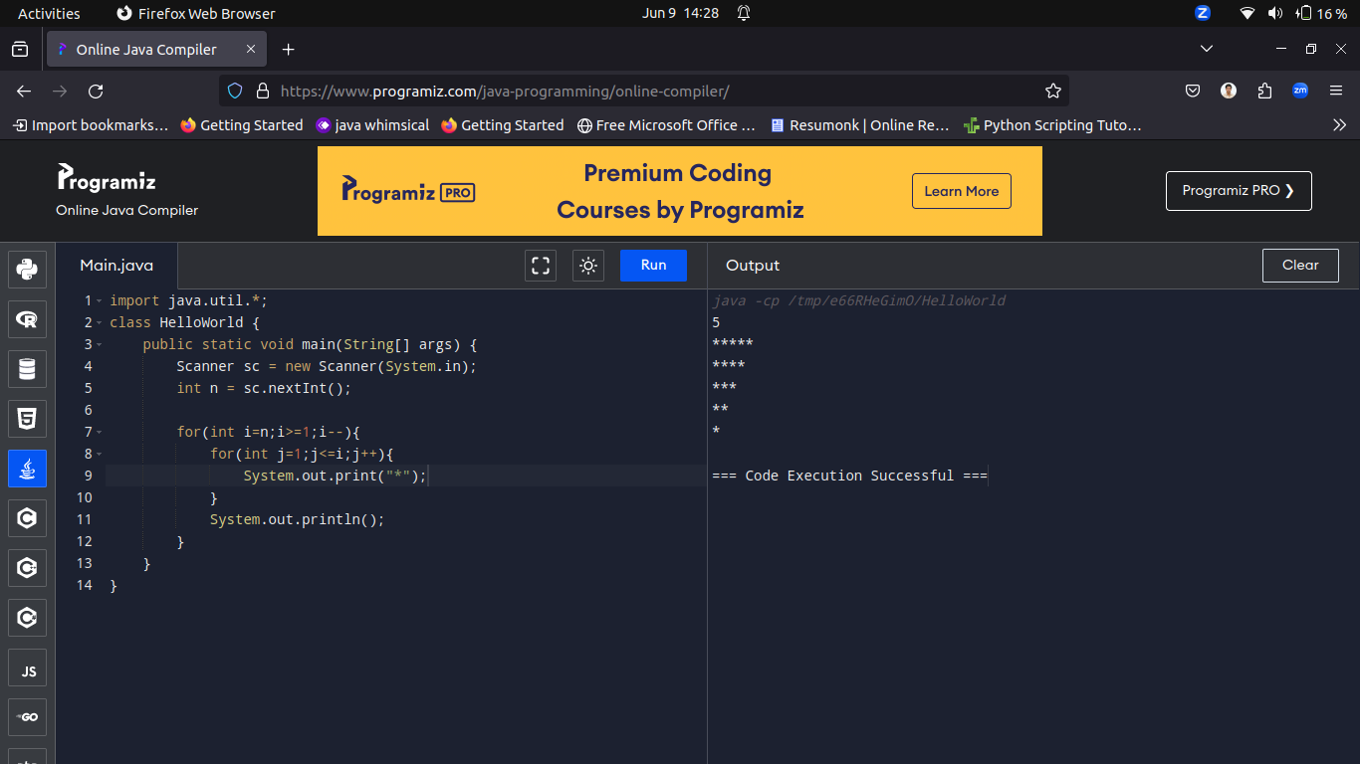
---------------------------------------------------------------------------------------------------------------------------------------------------------
Q4.WAP to print following pattern.
Input:5
Output:
ABCDE
FGHIJ
KLMNO
PQRST
UVWXY

Solution:
import java.util.*;
class HelloWorld {
public static void main(String[] args) {
Scanner sc = new Scanner(System.in);
int n = sc.nextInt();
int k=65;
for(int i=1;i<=n;i++){
for(int j=1;j<=n;j++){
System.out.print((char)k);
k++;
}
System.out.println();
}
}
}

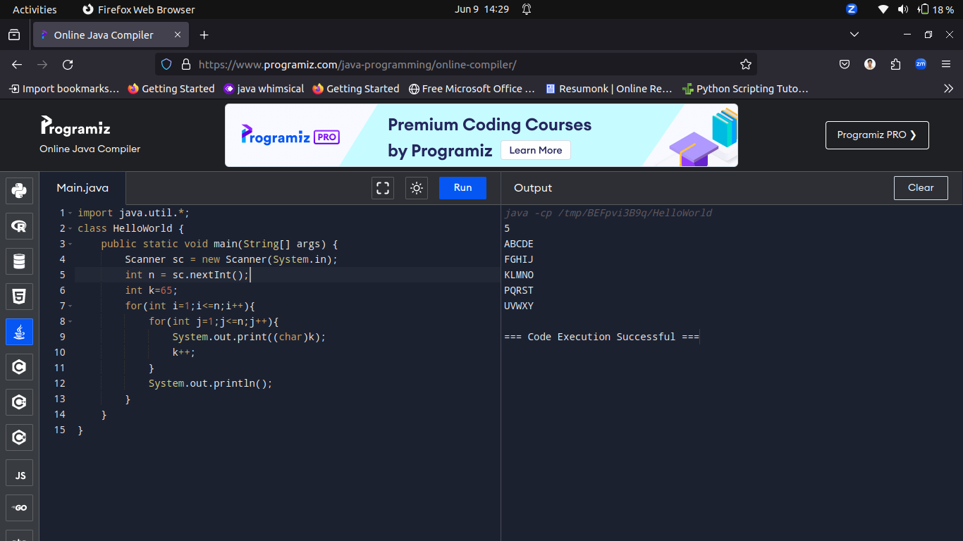

---------------------------------------------------------------------------------------------------------------------------------------------------------
Q5.WAP to print following pattern.
Input:
5
Output:
*****
****
***
**
*

Solution:

import java.util.*;
class HelloWorld {
public static void main(String[] args) {
Scanner sc = new Scanner(System.in);
int n = sc.nextInt();

for(int i=n;i>=1;i--){
for(int j=1;j<=i;j++){
System.out.print("*");
}
System.out.println();
}
}
}

---------------------------------------------------------------------------------------------------------------------------------------------------------
Q6.WAP to print following pattern.
Input:
5
5

Output:
*****
*****
*****
*****
*****

Solution:

import java.util.*;
class HelloWorld {
public static void main(String[] args) {
Scanner sc = new Scanner(System.in);
int n = sc.nextInt();

for(int i=1;i<=n;i++){
for(int j=1;j<=n;j++){
System.out.print("*");

}
System.out.println();
}
}
}
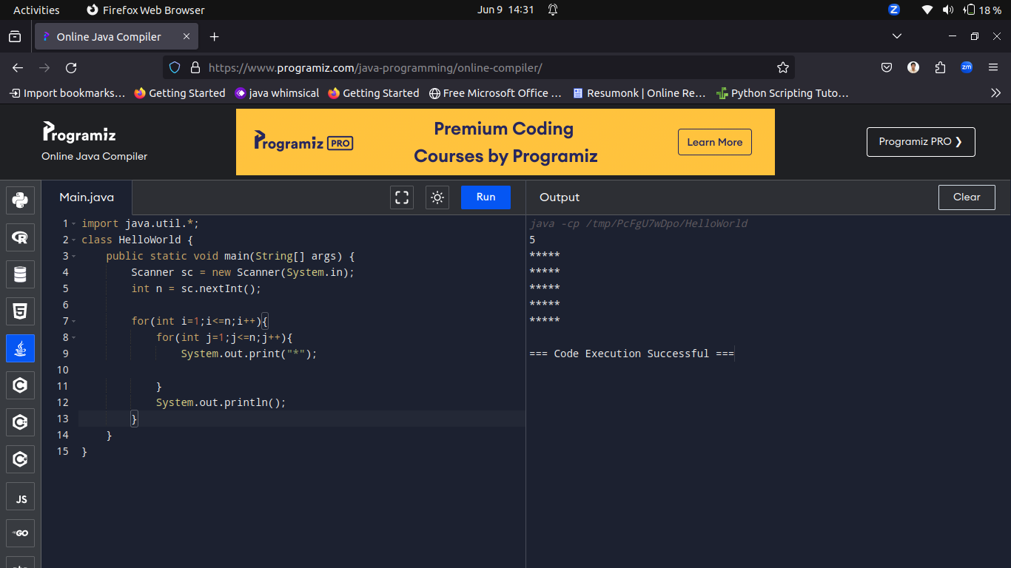

---------------------------------------------------------------------------------------------------------------------------------------------------------
Q7.WAP to print following pattern.
Input:5
Output:
12345
12345
12345
12345
12345

Solution:
import java.util.*;
class HelloWorld {
public static void main(String[] args) {
Scanner sc = new Scanner(System.in);
int n = sc.nextInt();

for(int i=1;i<=n;i++){
for(int j=1;j<=n;j++){
System.out.print(j);

}
System.out.println();
}
}
}

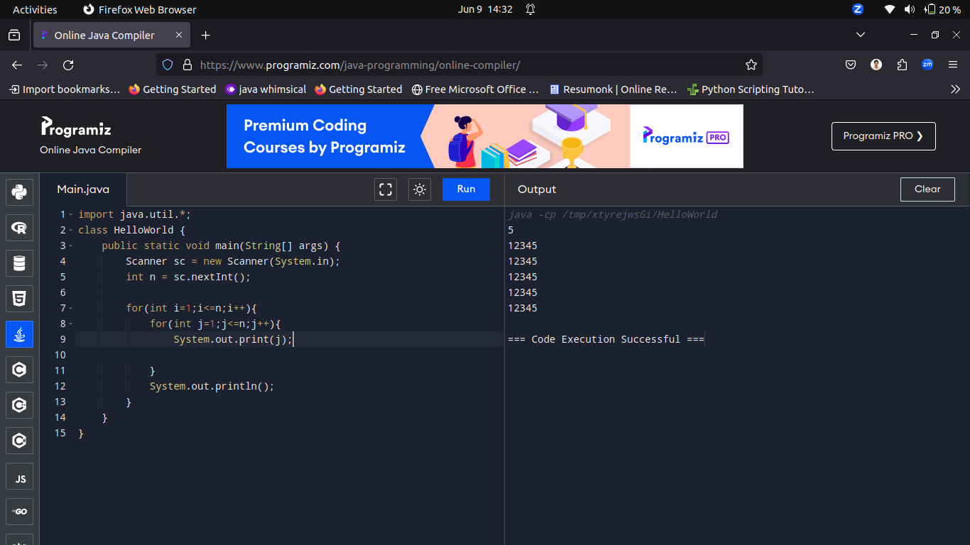

---------------------------------------------------------------------------------------------------------------------------------------------------------
Q8.WAP to print following pattern.
Input:5
Output:
1*2*3
1*2*3
1*2*3
1*2*3
1*2*3

Solution:

import java.util.*;
class HelloWorld {
public static void main(String[] args) {
Scanner sc = new Scanner(System.in);
int n = sc.nextInt();

for(int i=1;i<=n;i++){
int k=1;
for(int j=1;j<=n;j++){
if(j%2==0)
System.out.print("*");

else
System.out.print(k++);

}
System.out.println();
}
}
}

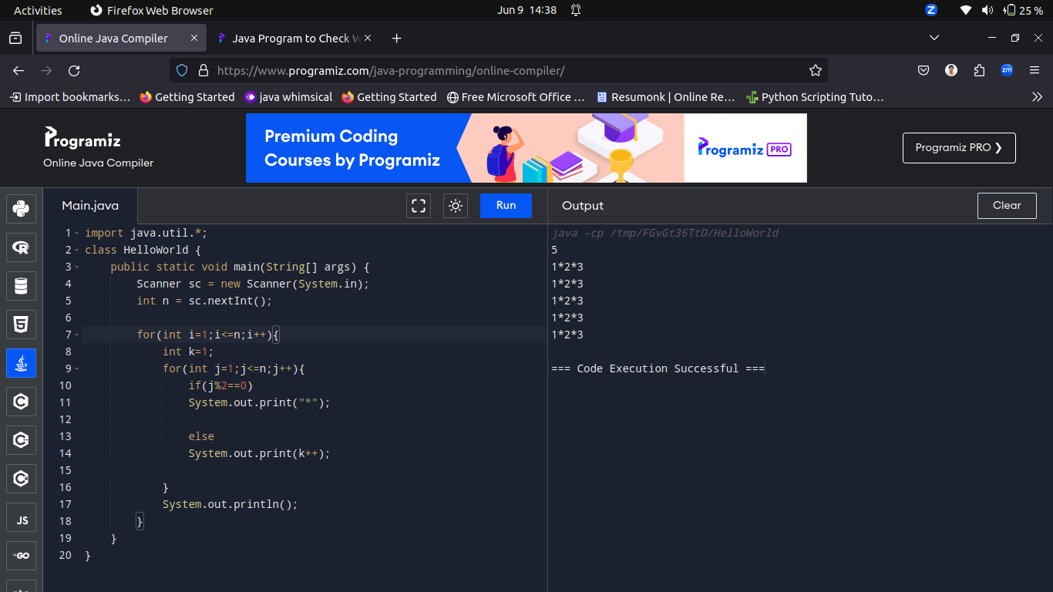

---------------------------------------------------------------------------------------------------------------------------------------------------------
Q9.Write a program to check whether a given number is prime or not.
Input:17
Output:
17 is a prime number.

Solution:

import java.util.*;
public class Main {
public static void main(String[] args) {
Scanner sc = new Scanner(System.in);
int num = sc.nextInt();
boolean flag = false;

for (int i = 2; i <= num / 2; ++i) {
// condition for nonprime number
if (num % i == 0) {
flag = true;
break;
}
}

if (!flag)
System.out.println(num + " is a prime number.");
else
System.out.println(num + " is not a prime number.");
}
}
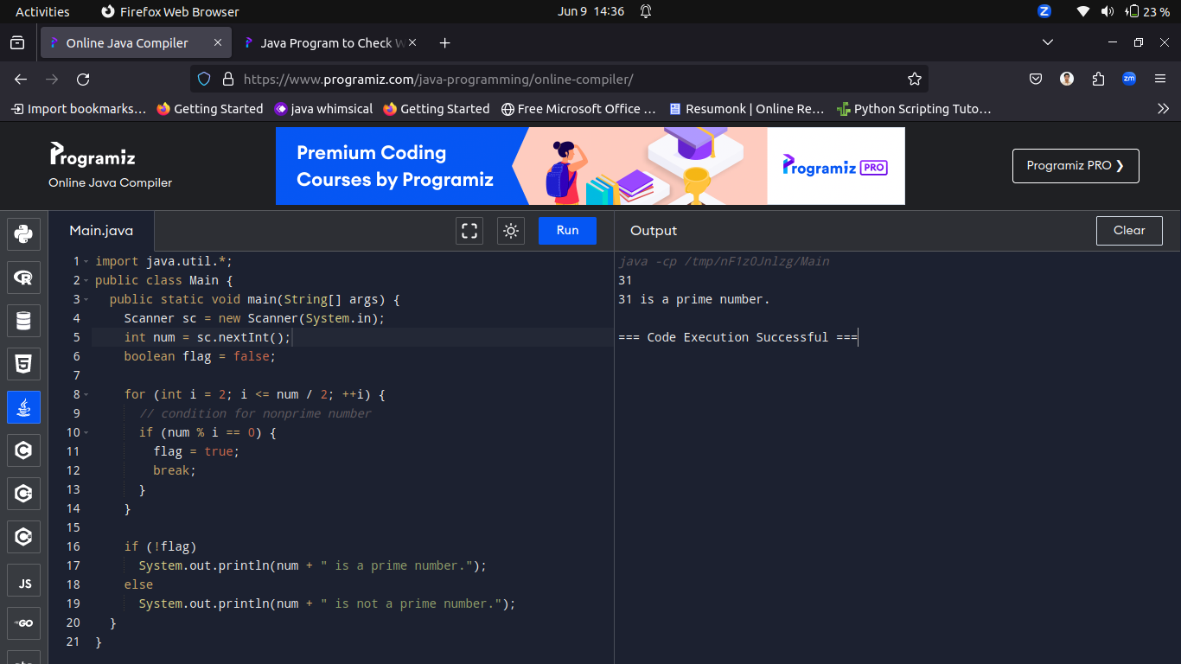

---------------------------------------------------------------------------------------------------------------------------------------------------------
Q10.Write a program to check whether a given number is a Harshad number or not.

Input: A single integer representing the number to be checked.

Output: Print "Harshad number" if the input number is a Harshad number, otherwise print "Not a Harshad number

Hint:
A Harshad number is an integer that is divisible by the sum of its digits.
For example, 18 is a Harshad number because 1 + 8 = 9 and 18 is divisible by 9.

Solution:

import java.util.*;
public class Main
{
public static void main(String[] args) {
Scanner sc = new Scanner(System.in);
int num = sc.nextInt();
int rem = 0, sum = 0, n;

n = num;

while(num > 0){
rem = num%10;
sum = sum + rem;
num = num/10;
}

if(n%sum == 0)
System.out.println(n + " is a harshad number");
else
System.out.println(n + " is not a harshad number");
}
}





